**Digital Marketing Weekly: Using images for more engagement on Twitter**

Twitter has become more visual in the past year by adding Twitter Cards and Periscope, a live video sharing feature. The Growing Returns team noticed that and decided to take advantage.

They started by adding imagery to tweets sharing third-party mentions of EDF. That made it easier to isolate a quote.

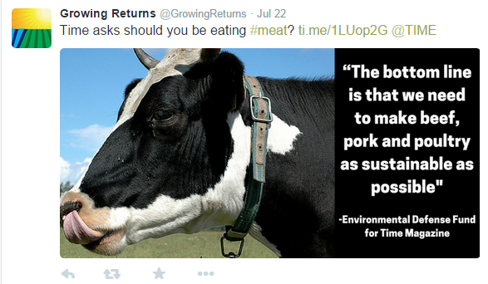

They also began pulling out key messages from Growing Return posts to overlay on images. This allowed them an easy way to promote one blog post several times.



**How did they do this?**

The Growing Returns team takes the photo featured in the article or blog post and turns it into a share image using a template created in [Canva.](https://www.canva.com/) This makes for a fast turnaround and ensures consistently branded imagery.

**Their returns?**

The [Growing Returns Twitter account](https://twitter.com/GrowingReturns) has seen an increase in followers from 600-850 in a matter of weeks.

Of course, it’s not all about the images. They spend an hour a day researching relevant hashtags, engaging with followers, searching terms like “agriculture” and “farmers” to find more opportunities to engage. They also keep an eye on Twitter Analytics to learn from what performs the best.